# Msc Programme:

**F21M:**

**Advanced Internet Applications**

# Course F21AS:

# Advanced Software Engineering

Group Report Stage 1

Miss Sakura Komiya

Mr Victor Godayer

Mr Dimitrios Tsoumanis

A description...

1. Duties

The work during the process of program implementation was approximately equally distributed. More specifically, Sakura provide the team with a frame to move in, as well as what type of items we are going to use, which are books in our case. On the other hand, it was Victor’s idea the implementation of the Abstract class and the Interface. Dimitrios did the discount calculation and the output files method. Victor worked for the Manager class, as well as for the Worker class, in order process part. Sakura did the JUnit part. In the report process Victor was mainly consecrate in the technical report. Dimitrios handled diagram, summary of who did what and the summary on decisions for items- format of ID’s. Sakura did most of the development report, and some part of the technical report. The bottom line is that no one did nothing on its own. Because we used google code: [*https://aes-dsv.googlecode.com*](https://aes-dsv.googlecode.com/) ,everything that someone did, was instantly available to the other parts, giving the possibility for a member of the group, to make any changes to improve the functionality of the program. One difficult part (time consuming) of the coursework, was the handling of exceptions, in order to cover all possible cases, that could lead to a ‘risky method’.

1. Specifications

This program meets the specification completely.

1. Summary

We use books as items. The format of ID’s for books goes like this:

* ID;[unit price];[quantity]

1. ID: is declared as a string originally, converted to an integer, consisting by a 3 digits number, making it a unique identification number (e.g. 402, 503,…)
2. [unit price]: is declared as a string originally, converted to a double
3. [quantity]: is declared as a string originally, converted to an integer

In the case of the orders, we use the following format:

* ID;[customerID ]; [itemID]; [quantity]

1. ID: is an integer starting from value 1
2. [customerID]: the ID of a Customer is composed by a KEY string and 3 digits separated with a hyphen. In our case we deal with two types of customers: VIP and STD (stands for standard). How the price is calculated in each case we will describe that below.
3. [quantity]: is declared as a string originally, converted to an integer

In both txt files: Items and Orders, details are separated with semicolon which will be used as tokens in browsing procession.

### Price Calculation

The basic logic will be based on the type of the customer and the quantity ordered. For a normal customer (e.g. ID = STD-001), if the quantity is over 50 there will be a discount of 10% whereas a VIP customer (e.g. ID = VIP-001) there is a basic discount of 10% even below 50 items and an additional discount of 5% for each range of 50. Here are some possible cases of pricing for a book with ₤5.00 as unit price:

* Orders with q = 49 (case 1 : quantity <50)
  + 1. VIP customers

*Total Price = (5.00 * 49) * 0.9 =* ***₤220.50*** *→ 10% discount*

* + 1. STD customers

*Total Price = 5.00 * 49 =* ***₤245.00*** *→ no discount*

* Orders with q = 100 (case 2 : 100 ≥ quantity ≥ 50)
  + 1. VIP customers

*Total Price = (5.00 * 100) * 0.9 – (5.00 * 100) * 0.05 =* ***₤425.00*** *→ 10% discount + 5%*

* + 1. STD customers

*Total Price = (5.00 * 100) * 0.9 =* ***₤450.00*** *→ 10% discount*

* Orders with q = 200 (case 3 : quantity over 100)
  + 1. VIP customers

*Total Price = (5.00 * 200) * 0.9 – [(5.00 * 200) * 0.05] * 3 =* ***₤750.00*** *→ 10% discount + three times 5% since quantity is three range of 50 over 50*

* + 1. STD customers

*Total Price = (5.00 * 200) * 0.9 =* ***₤900.00*** *→ 10% discount*

1. UML diagram

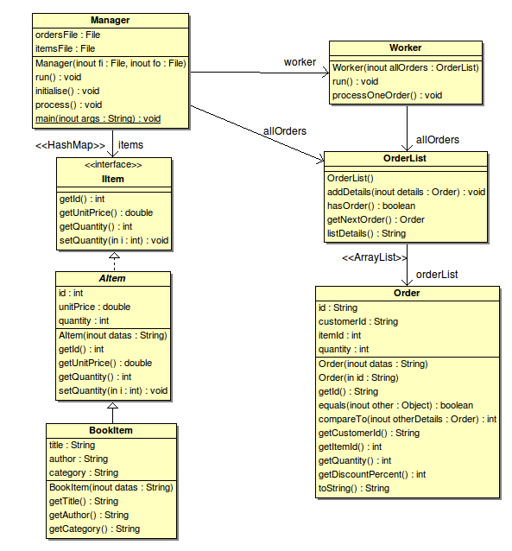

1. Technical Report

In this paragraph we will dress a technical description of the main functionality implemented in each class.

The project is composed by 5 concrete classes, 1 abstract class and one interface.

The concrete classes are *Order*, *Worker*, *BookItem*, *OrderList* and *Manager*; the abstract one is *Aitem* and the inrerface is *Iitem*.

Order class:

* *Constructor: it* takes as parameter an array of *String* and map its elements to the corresponding class's attributes. A specific method *parseInfo is dedicated to realise this task. It handles the parsing of each element of the array and throws an Exception with a relevant message in case of parsing error. Below are some code samples showing the Exception logic used:*

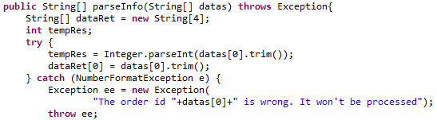

*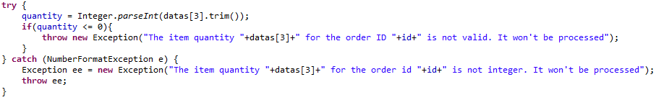In this last sample, we first parse the string to integer, and if it fails, the catch statement intercepts the NumberFormatException and we replace it by a more generic Exception but with a more specific and relevant message. If the parsing occurred correctly, then we check incoherent value such as a negative or zero value.*

*All these Exception are thrown upward to the constructor then to the Manager class which instantiates the Order class. We will see below how Manager class handles these Exception.*

* *getDiscountPercent(): depending on the type of the client (VIP or STD) and the amount of items wanted, we make the calculation and return the percentage.*

OrderList class:

* *addDetails(): As we needed to check if an order ID was not already existing, we needed to use the datastructure allowing to perform this check. The HashMap was the appropriate one. It maps a value for a given key. Here the key is an integer (the order id), and the value the order object.*

*So when this method is called, we check if the order given is not already in the orderList variable by checking if its ID is not already in the keys set.*

*According the result we add the order or not.*

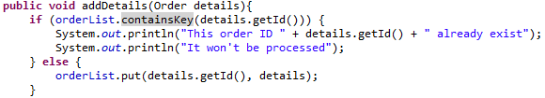

We also kept the original attribute which was an ArrayList of Order. We insured the link between both data structures by calling the method values on the HashMap typed variable. This procedure is wrapped in the *generateArrayList() which is called from within the Manager initialise() method.*

IItem interface:

This interface provides the main functionalities available for a further implemented *AItem* typed object.

AItem abstract class:

In this abstract class, implementing the *Iitem inteface,* we gather all the main attributes which must be available for all sub classes which would be implemented. Even though there is no abstract method but for facilitating further work, we decided to declare the class as abstract.

* *Constructor: first it check if the size of the array length of datas is relevant for the next step. Then it parses the string to the appropriate type for the corresponding attribute. The constructor throws any Exception upward to the constructor caller.*
* *Getter and Setter: the class also implements the main getter and setter.*

BookItem class:

* *Inheritance:* this class inherits from the superclass abstract *AItem*. Then it inherits the generic attributes *id, unitPrice and quantity.*
* *Extension: i*t also declares more *book-related* attributes and methods. The main duties of this class are, to get the title, the author and the category of the book.
* *Constructor: it plays the same role as it parent class except that there is no parsing since our new attributes are strings.*

Manager class:

It the class that handles both items and orders file objects.

* *main(String args[]): the main method deal with the input argument: it checks if both arguments are provided and also checks that the files exist on the system. If both condition are completed, the a new instance of the Manager class is created and the run method is called to trigger the whole process.*
* *Initialise(): this method handles the instantiation of the objects corresponding to the file parsing. Each file is read line by line and for each one, we instantiate the object according the file being read. If the object instantiation fails because an Exception is caught, then the message of the Exception is displayed in the console, and the object is not added to its corresponding collection. Below a code sample for the Order object instantiations process:*

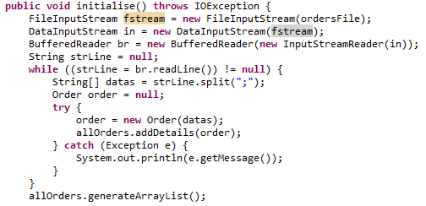

We try to create 3 new objects, and a catch in order to handle the risky method.

Another case of try/catch is the following:

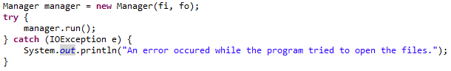

when we run the reference variable manager and use catch for case occur reading txt files.

Worker class: We use this class in order to get the output.txt, with the results, according to the specifications.

A description...

We try to create the output.txt folder, and in case it fails it will display the message with the error in trying.

Interface describes the functionality of an object. We could also use it in order to avoid “multiple Inheritance” in future cases . Interface will provide a role that other classes can play, regardless of where those classes are in the inheritance tree.

We have created an abstract class in order to define a template for a group of subclasses and use at least some implementation code that all subclasses can use. With abstract class we can guarantee that nobody can make objects of that type.

**Data Structures**

We use HashMap collection, because we want to make something like property list, where you provide a key and it gives back a value. In our case we use : “HashMap <Integer, IItem>”.

Integer is the value and IItem the key. We also use : “HashMap <Integer, Order>”,

There is also the ArrayList data structure,which comes as a default in the OrderList class

1. Development Report

Initial development schedule:

A description...

* Implementation
  + 1. Abstract Item class and Item Interface – Victor Godayer
    2. Updating warehouse function – Sakura Komiya
    3. Modifying the Worker class for order processing – Victor Godayer
    4. Discount calculating method – Dimitris Tsoumanis
    5. Adding output files writing method – Dimitris Tsoumanis
* Testing
  + 1. JUnit testing – Sakura Komiya and Victor Godayer
    2. Any modifications and correction to the code according to the testing results – each member of the team who has implemented the code.

Generally we abide the initial project, as much as possible. We had arranged meetings, in person, once per week, in order to solve the encountered problems, as well as to propose each one, ideas about the implementation of several frames of the program. What was quite “painful”, was the exceptions handling, from the point that all possible possibilities should be covered.

For the test process, we have used two input txt files, the Items and the Orders,

Items:

401;20.4;200; Oxford Dictionary;Oxford; Dictionary

402;12.34;46; Larousse Dictionary; Larousse; Dictionary

503;5;34; Internet for All; J Smith ; Textbook

200;5;34; Conquering the galaxy; D Vader ; Literature

Orders:

1; STD-001;402;60

2; VIP-002;503;10

3; STD-003;402;3

4; STD-002;401;51

5; VIP-002;401;1

The output result is as shown:

ORDER ID : 1 ITEM ID : 402 QUANTITY ORDERED: 60

CUSTOMER TYPE : STD

ORIGINAL COST : 740.4

DISCOUNT COST : 666.36

PROCESS STATUS : Unprocessed

CAUSE : Stock running low

---------------------------------------

ORDER ID : 2 ITEM ID : 503 QUANTITY ORDERED: 10

CUSTOMER TYPE : VIP

ORIGINAL COST : 50

DISCOUNT COST : 47.5

PROCESS STATUS : Processed

---------------------------------------

ORDER ID : 3 ITEM ID : 402 QUANTITY ORDERED: 3

CUSTOMER TYPE : STD

ORIGINAL COST : 37.02

DISCOUNT COST : 37.02

PROCESS STATUS : Processed

---------------------------------------

ORDER ID : 4 ITEM ID : 401 QUANTITY ORDERED: 51

CUSTOMER TYPE : STD

ORIGINAL COST : 1040.4

DISCOUNT COST : 936.36

PROCESS STATUS : Processed

---------------------------------------

ORDER ID : 5 ITEM ID : 401 QUANTITY ORDERED: 1

CUSTOMER TYPE : VIP

ORIGINAL COST : 20.4

DISCOUNT COST : 19.38

PROCESS STATUS : Processed

---------------------------------------

SUMMARY

Total income: 1706.62

Total item sold: 65

Total customer: 4